
Our commitment to human rights
Modern Slavery Statement of CRH plc

For the year ended December 31, 2024



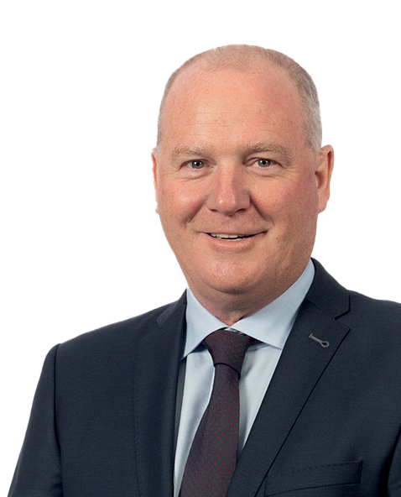
Contents
2024 actions and achievements 1
Ongoing goals and targets 1
Responsible corporate governance 2
Business overview 3
Our policies 5
Our supply chain risks 6
Identifying, mitigating and managing risk 8
Internal due diligence 11
Supply chain due diligence 12
Global direct sourcing audit summary 13
Training 15
Speak Up Policy 15
Note on forward-looking statements 16
Appendices - Country specific requirements 17

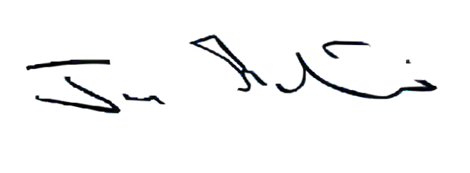
This statement was approved by the Board of Directors of CRH plc on 9 May 2025 and signed on behalf of the Board by Jim Mintern, Chief Executive Officer.

By:

All statements are available on our corporate website here.
* The Australian Commonwealth Modern Slavery Act 2018 and the Canadian Fighting Against Forced Labour and Child Labour in Supply Chains Act 2023. CRH’s policy statement under the German Supply Chain Due Diligence Act is available here: https://www.crh.com/global/europe/germany.
1 Modern Slavery includes forced labor, compulsory labor, child labor, human trafficking, and any form of slavery or servitude.
Introduction

This statement is made in compliance with Section 54(1) of the UK Modern Slavery Act 2015, the California Transparency in Supply Chains Act and other applicable legislation*, and sets out the measures CRH plc and
its subsidiaries (collectively ‘CRH’ or the ‘Group’) took during the financial year ended December 31, 2024 in furtherance of the goal to prevent any form of Modern Slavery1 within its own businesses or supply chains.
CRH believes that Modern Slavery, in all its forms, is unacceptable and that all CRH companies must do everything they can to prevent any form of Modern Slavery or any other unethical behavior in their businesses and supply chains.

At CRH, we do not tolerate any form of modern slavery and we expect the same zero tolerance approach from both our customers and suppliers. This statement
sets out our strong governance processes for the protection of human rights.






Continue to develop and expand the coverage of our Modern Slavery e-Learning module to address new or emerging risks in more detail and to ensure the training is available to additional colleagues across our business.

Our Enterprise Risk Management processes provide a framework for our continued efforts to assess human rights and modern slavery risks (see pages 75-80 of the CRH 2024 Sustainability Performance Report for more information, available on crh.com here).

Expanding the coverage of our due diligence processes utilizing best practices from industry research with the aim of enhancing the effectiveness of our processes and collaborative remedial actions.

We strive to have a culture of safety and wellness, with a goal of “zero harm” across the organization. CRH’s mandatory Life Saving Rules clearly define activity-specific safety methodologies, procedures and controls and focus on the top causes of fatalities. By combining new technologies and initiatives across CRH, we continue our drive to meet our ambition of zero harm.

2024 actions and achievements Ongoing goals and targets

Review and update this annual statement to detail our governance principles and processes for managing human and labor rights (see page 8 for further details).


Training and raising awareness

We continue to broaden the assignment of our Modern Slavery e-learning to additional relevant employees across the Group. This module educates relevant teams on the key indicators of modern slavery across the supply chain, related human rights concerns, and the risks they pose to our business. The training also provides an overview of our policies, systems and processes.
Know Your Supplier

Our Supplier Code of Conduct (‘SCoC’) is key to our supplier due diligence processes and sets out our expectations for our suppliers.
Our due diligence processes include a SCoC acknowledgement, questionnaires and third-party assessments. Third-party assessments of suppliers can include automated data points on financial health, sanctions screening and adverse media reports in areas like discrimination, workforce rights, human rights, modern slavery, workforce disputes and workforce health and safety issues.

Code of Business Conduct

Our Code of Business Conduct (‘CoBC’) sets out our standards of legal, honest and ethical behavior, which govern the activities and conduct of our management and employees. Our CoBC (available on crh.com) includes by reference our Speak Up Policy, which encourages a culture where individuals can raise good faith reportable concerns such as unsafe, inappropriate or illegal behavior or violations of any CRH policies or local laws. Everyone who works for CRH has a duty to read, understand, and abide by the CoBC. Relevant employees are required to complete formal CoBC training on an annual basis.
Defining salient human rights issues

We recognize the importance of engaging and collaborating with our stakeholders to further develop our culture of doing the right thing. This includes our annual impact assessment approach for salient human rights impacts and examination of risks to our operations, acquisitions, and supply chain.
CRH is a signatory to the United Nations Global Compact and continues to report its performance across the four key areas of human rights, labor, the environment and anti-corruption in 2024.
This report brings greater transparency in the areas of human rights and sustainability and again demonstrates our commitment to responsible business. Collaborating and partnering with other
like-minded organizations is a key driver to maintaining and increasing standards across our industry and beyond, helping to grow our culture of doing the right thing.



Responsible corporate governance
CRH
At CRH, what we make is essential to life and living because our materials, products, and solutions define how our world is built.
We have a relentless drive and a capability for solving some of the major challenges of our time. We know that by standing together we can make the biggest impact. In 2024, our global footprint spanned 28 countries and 3,816 operating locations, serving customers across the building materials sector. Our operating companies manufacture and supply a range of integrated building materials, products and innovative solutions which can be found throughout the built environment.
CRH companies purchase more than $20 billion worth of goods and services each year from more than 100,000 suppliers.
Our purchases largely align with our operational footprint with the majority of spend in North America and Europe.
We also extract raw materials such as aggregates, sand, and gravel to use in our own processes, as well as to supply external customers. Responsible sourcing across our supply chains is critical to maintaining business continuity, upholding human rights, and managing downstream environmental impacts.

Expectations
We respect internationally recognized human rights – as set out in the International Bill of Human Rights and the International Labour Organisation’s Fundamental Principles and Rights at Work - across our operations and extended supply chain.
We are a signatory of the UN Global Compact, the world’s largest sustainability initiative with ten universal principles, including human rights.

Governance strategy
At CRH, our strong governance structures are fundamental in embedding sustainability throughout our organization. Sustainability, including climate change impacts, is embedded in our strategy, business model, Sustainability Framework and Environmental Policy (see page 82 of the CRH 2024 Sustainability Performance Report).
The CRH Board has delegated primary responsibility to the Safety, Environmental & Social Responsibility (‘SESR’) Committee for monitoring developments related to sustainability, including climate, and providing strategic direction, oversight and support to the Board on these important topics. The SESR Committee meets at least quarterly and detailed reports of the discussions at the meetings are circulated to the Board for consideration thereafter.
In the area of procurement specifically, Divisional Presidents, Regional Heads of Procurement, and other key members of leadership oversee procurement functions through regional reporting structures and the global procurement team is supported by the Procurement Head of Sustainability, Risk, Innovation & Market Intelligence.
In addition, the wider CRH Sustainability team facilitates reporting in all areas of sustainability and our global Legal & Compliance function provides support to both procurement and sustainability in these responsibilities.

Business Overview

Leading the transition to smarter, more sustainable construction.

CRH reimagines and reinvents new ways to build, connect and improve our world. We provide the solutions that solve complex construction and building materials-related challenges in major markets in North America and Europe. Our solutions play an important role in shaping a more sustainable built environment and through the use of technology and innovation, CRH is helping to reinvent the way our world is built. CRH is an Irish incorporated company, with a primary listing on the New York Stock Exchange (NYSE) and a secondary listing on the London Stock Exchange (LSE).
Leadership Positions2
#1
Aggregates
North America
#1
Asphalt
North America
#1
Concrete Products
North America and Europe
#3
Readymixed Concrete
North America
#3
Cement
North America and Europe
Revenues
$35.6bn
+2%
$32.7bn
$34.9bn
$35.6bn
2022
2023
2024

Revenues by Division

35%

65%

Americas International
Revenues by End-Market1
35%
35%
30%
Infrastructure Non-Residential
Residential

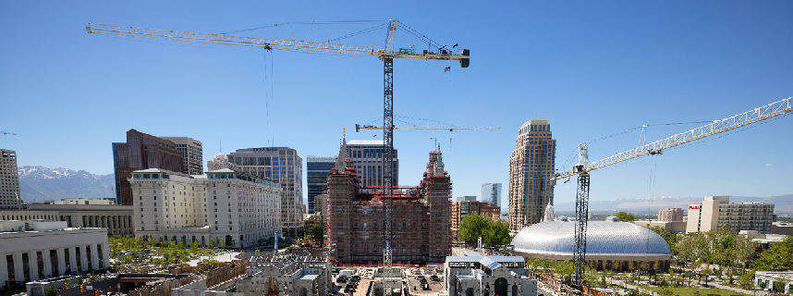
Our Global Business



ESG
Sector leading ESG ratings

#1
Market Leadership Positions

28
Countries
3,816
Locations

c.79,800
People

- For more information, please see the CRH’s 2024 Annual Report on Form 10-K available on crh.com
1 End-market exposures are approximate and derived from management estimates.
2 Market leadership positions are based on annualized sales volumes. This includes volumes which are used internally (e.g. aggregates supplied internally for cement production).
- For more information on CRH’s operational footprint, please see here

Business overview - continued

CRH is at the forefront of the development of more sustainable and better performing materials. Through our differentiated solutions strategy and unrivaled scale, CRH works with customers across the entire construction value chain, uniquely integrating materials, products and services to better serve our customers’ needs and drive repeat business. As our customers’ needs continue to evolve, our solutions help them to build simpler, safer and more sustainably.






Complete Solutions
Products & Services
Asphalt
Paving & Construction Services
Readymixed Concrete
Infrastructural Concrete
Infrastructure Structure Products
Architectural Products
Essential Materials
Aggregates
Cement
CRH is a leading producer of aggregates and cement, backed by a significant reserve
base across an extensive network of quarries. These materials are an essential element of almost every construction project. They are used in a variety of value-added construction products within our connected portfolio including concrete, concrete products and asphalt.
CRH is investing in innovation and new technologies including recycling to increase efficiency and reduce the carbon footprint of essential materials in line with evolving customer and societal demand.

Road Solutions  CRH is the largest road builder in North America working with state and federal transport authorities to design, build, upgrade and maintain the vast road infrastructure networks that connect the communities in the markets we operate in.  We build and repair surface transportation infrastructure by applying our unique capability to adapt materials, products and services  to offer bespoke sustainable solutions that ensure higher quality and better value for the customer and end-user.   | Building & Infrastructure Solutions  We work with large critical infrastructure owners to provide solutions to collect, connect and protect the delivery of vital infrastructure including municipal water systems, data centers and energy networks.  Customers work with CRH due to our ability to provide highly specified and innovative solutions that address the complexity involved in delivering critical infrastructure. Our value-added approach includes design, specification, manufacturing, installation and maintenance.  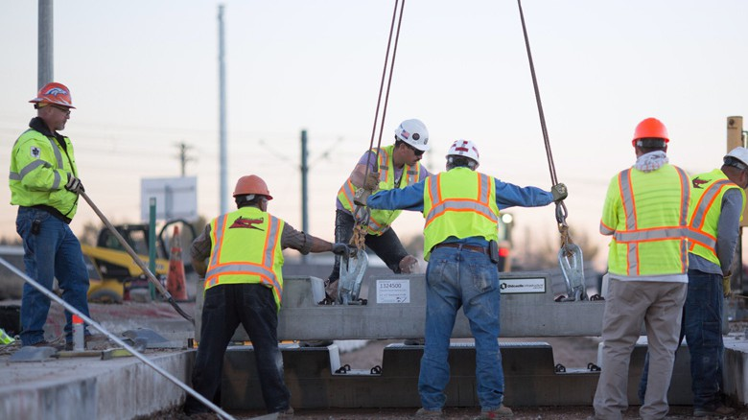 | Outdoor Living Solutions  CRH is a leader in solutions which transform outdoor environments into dynamic living spaces so that communities, businesses and homeowners can “Live Well Outside”.  We provide customers with a full service offering, from materials and products to digital design services and logistics.  Our connected portfolio of solutions incorporates hardscapes, masonry, fencing, railing, lawn and garden, pool finishes and composite decking.  

Our policies

CRH implements responsible practices across our businesses and in our value chain through the following key codes and policies, which outline our high standards and core values, including the prevention of modern slavery*:
Social Policy

The Social Policy is outlined in the CRH 2024 Sustainability Performance Report on page 83 (available on crh.com here) and requires all CRH companies to:


Comply at a minimum, with all applicable legislation and continuously improve our social stewardship, aiming at all times to meet or exceed industry best practice standards
 Support freedom of association and recognize the right to collective bargaining

Apply the principle of equal opportunity, valuing diversity regardless of age, gender, disability, creed, ethnic origin or sexual orientation, while insisting that merit is the ultimate basis for recruitment and selection decisions
Manage our businesses in a fair and equitable manner, meeting all our social responsibilities including working conditions, as both a direct and indirect employer

Ensure that we deal responsibly with our suppliers and customers in accordance with our Code of Business Conduct, Supplier Code of Conduct and proper business practice
 Prohibit forced, compulsory and child labor in all forms including modern slavery
Code of Business Conduct
At CRH, our Code of Business Conduct (CoBC) sets out our standards of legal, honest and ethical behavior, which govern the activities and conduct of our management and employees. It provides clear guidance for recognizing and addressing any ethical or legal issues that our management and employees may encounter. In order to live up to our values as a company, everyone has a role to play and, for this reason, “It Begins with Me” is a recurring phrase within the CoBC. Our CoBC is available in multiple languages on crh.com here.
 Speak Up Policy
Our Speak Up Policy encourages a culture where employees, independent contractors, customers, suppliers and other stakeholders can raise good faith reportable concerns such as unsafe, inappropriate or illegal behavior, or violations of any CRH policies or local laws. Our Speak Up Policy is available in multiple languages on crh.com here.
 Supplier Code of Conduct
Our SCoC sets out the supplier requirements to meet our standards in respect of health and safety, human rights and environmental stewardship.
The SCoC is based on our Framework for a Sustainable Future and is reviewed on an ongoing basis. Supplier acknowledgment of commitment to the SCoC is a requirement in our general purchase conditions to ensure that our suppliers are aligned with our values. Acknowledgment of the CRH SCoC is a precondition to submit responses to all e-tenders.
Our suppliers must specifically undertake the following in relation to modern slavery:


Prohibit all forms of modern slavery including forced labor, bonded labor, compulsory labor and child labor

Support the principles of equality, inclusion and respect when dealing with potential, current, and past employees

Respect freedom of association and the effective recognition of the right to collective bargaining by employees
 Compliance with all relevant human rights legislation
*Other Policies are available on pages 82-83 of the CRH 2024 Sustainability Performance Report here.

Our supply chain risks

Identifying, mitigating and assessing the effectiveness of our approach

We seek to align our major areas of spend with ISO 20400
- Sustainable Procurement best practices. Our assessment includes criteria for areas that affect our supply chain including health, safety, labor practices (human rights, modern slavery, human trafficking), circularity and compliance with regulations.
The assessment of risks within CRH’s supply chain varies in accordance with the potential risks. CRH Procurement employs third-party systems to independently monitor risks for selected suppliers continuously. Based on the risks identified, our teams review appropriate action within their areas.
Country risk is a significant part of this assessment, and the vast majority of our suppliers replicate our operational footprint in North America and Europe. We are continually improving our spend visibility platforms to enhance country insights for
suppliers in countries with a higher prevalence of modern slavery This allows us to focus our resources on suppliers with a higher potential for issues with modern slavery.
When specific risks are identified, this approach enables us to implement further due diligence processes, such as the SCoC due diligence process, third party assessments and additional contractual assurances to manage supplier performance relating to the potential risks. We do this with human rights issues and other issues covered by ISO 20400.
Following the divestiture of the Oldcastle Building Envelope business in 2022, CRH no longer has any businesses with involvement in conflict minerals.

Increasing external spend %

Our supply chain risks - continued











Identifying, mitigating and assessing the effectiveness of our approach
Logistics services
20%
Production Equipment & Services
18%
Raw materials
15%
Energy
12%
General services
9%
Building components and manufacturing materials 6%
Mobile equipment
6%
Chemicals
5%
Facilities management and estates
4%
Packaging
2%
IT and telecoms
1%
Increasing modern slavery potential impact

Sustainable procurement approach
We equip businesses with the tools to understand, manage and assess the effectiveness of our approach to responsible supply chains through:
- Our regional reporting structures that oversee procurement functions and feedback received by procurement teams, including from working groups that assess the alignment of categories with the needs of operating companies.
- Assessing risk at a supplier level, an operating company level using data collected through the Enterprise Risk Management process (see page 75 of the CRH 2024 Sustainability Performance Report for more information, available on crh.com here), a category level and at a country level utilizing internal and external data sources, in line
with ISO 20400 – Sustainable Procurement best practice. This includes half year risk reviews in connection with the Enterprise Risk Management process.
- Variety of supplier selection and ongoing assessment processes implemented across operating companies, including sanctions screening, supplier’s business relevance, and reviews of a supplier’s approach to environmental, social and governance issues, as necessary.
- Annual procedures to encourage our operating companies’ active engagement in requiring SCoC acknowledgment from suppliers.
Non-compliance with the SCoC can have several consequences, including exclusion from any current or future tendering process or termination of contract.
However, our preference is to work with our suppliers to develop remediation plans when issues are identified, and build the capacity of suppliers to properly and continuously manage
these issues.

Identifying, mitigating and managing risk


Over the years we have refined our approach to risk management, embedding it into our businesses’ processes. This enables us to identify and evaluate key threats and opportunities, allowing us to make informed decisions and remediate issues effectively. Our core salient human rights have remained similar to previous years and are outlined below, which we consistently monitor to identify any issues.
Grievance mechanisms1 
Our Speak Up Policy and CRH Hotline provide effective grievance mechanisms for all stakeholders to report good faith reportable
concerns of wrongdoing within CRH. The Hotline is publicly available and therefore operates at Group and site level, ensuring potentially affected parties have a trusted mechanism to raise good faith concerns, which are professionally investigated.
Our Commitment
CRH is committed to doing business in a sustainable, responsible and ethical manner.
Our Actions
- Everyone at CRH must comply with the Code of Business Conduct, which includes a module on Respect and refers to the Speak Up Policy.
- Everyone at CRH must comply with our Social Policy, which includes our prohibition of modern slavery.
- Relevant employees are required to complete formal CoBC training on an annual basis.
Labor rights 
CRH believes that all its employees should be treated fairly and equitably, free from discrimination, have freedom of association and favorable conditions of pay and employment.
We also seek to ensure that all those working on our sites, both employees and contractors, are working freely and treated with respect.
Our Commitment
At CRH we are committed to creating a culture where everyone feels respected, listened to, valued, and treated fairly.
Our Actions
- Our Global Inclusion & Engagement Council sets the global strategy and ensures alignment with the business strategy. The Council is chaired by our Chief Executive Officer.
- Our Annual Review processes collect data around the working conditions of our employees and contractors. For more information on our labor practices see page 63 of the CRH 2024 Sustainability Performance Report.
- Managers at CRH are responsible for implementing the Social Policy, supported by a network of HR managers and regional and company specialists, working to ensure fair and equitable remuneration for all employees.
- Everyone at CRH must comply with our Code of Business Conduct.

Local community rights 
Strengthening relationships and trust with local stakeholders enables businesses to identify potential and current challenges within the community and drive positive impact. It is important that we prioritize the health and safety of the
communities where we operate and respect their land rights through free, prior and informed consent.
Our Commitment
CRH aims to use our reach and influence to positively impact our local
communities.
Our Actions
- A target of 100% of companies to have Community Engagement Plans by 2030.*
- Investing in community relations and development and aligning our transition planning where we can most effectively support our people and communities.
For further information on local communities refer to pages 67 to 69 of the CRH 2024 Sustainability Performance Report.


* The Canadian Fighting Against Forced Labour and Child Labour in Supply Chains Act 2023 requires reporting on any measures taken to remediate the loss of income to the most vulnerable families that results from any measure taken to eliminate the use of forced labor or child labor in its activities and supply chains. Our goal is to work towards a better understanding of any potential impacts that CRH’s due diligence processes may have on the most vulnerable families to allow for the
Relevant stakeholders
- Employees
- Contractors
- Third parties
- Workers in the supply chain
- Local communities
working on our sites  Partners
Labor rights of those working in our extended supply chain  Our operating companies purchase more than $20 billion worth of goods and services each year. The health and safety, working conditions, labor rights and
access to grievance mechanisms to raise concerns of the workers within this
supply chain must be protected.
Our Commitment
We expect our over 100,000 suppliers worldwide to match our unwavering commitment to good ethical practices. We work with suppliers to promote human rights.
Our Actions
- Category level assessments in line with ISO 20400.
- Supplier Code of Conduct.
- Review labor practices annually.
- CRH Hotline publicly available for employees and stakeholders to report good faith grievances and concerns.

Health & Safety 
Due to the nature of the building materials industry, certain activities carry inherent risks that may impact health and safety. We prioritize the health and safety and well being of everyone who interacts with our business.
Our Commitment
We believe everyone working on our sites has the right to a safe and healthy workplace. Our ambition is to have a culture of safety and wellness, with zero harm across the organization.
Our Actions
- Investing in safe systems by implementing the CRH Life Saving Rules.
- Clear focus on eliminating hazards at source.
- Employee and contractor engagement and training.
- Continuing to protect employees during conflict.
- For further information on health and safety refer to pages 53 to 59 and 63 to 69 of the CRH 2024 Sustainability Performance Report.

development and subsequent implementation of remediation plans to address them. An initial step in this regard are CRH’s community engagement efforts and its goal to expand these efforts across CRH operating companies.
1 The CRH Hotline is publicly available and therefore available to all relevant stakeholders.

Case studies

Safety & well-being
When it comes to our road construction and maintenance services, recent trends show an increase in motor vehicle accidents and work zone intrusions in many regions, both within and near some of our own work zones. To help address this CRH continues to enhance the safety surrounding work-zones on roads and highways, rolling out a range of initiatives and systems.
For example, CRH Canada, in CRH’s Americas Division, has launched an initiative to raise public awareness about the issue of work zone intrusion. The campaign, called “I Work Here”, used digital billboards across major highways where we operate featuring employees and was a collaborative effort involving health and safety, operations, and communications teams. The aim of this was to help build a more personal connection to impact driver care and behavior.
We are also continuing to enhance our innovative “AWARE” system, a sentry unit that provides advanced warning to motorists as they approach the work-zone and also alerts our workers to traffic encroaching on the
CASE STUDY

work zone and potentially threatening workers’ safety. The AWARE system uses lights and sirens to warn drivers up to 600 feet before they come into potential contact with our workers. The system sends an emergency alert to our employees if a vehicle is approaching too fast.
Currently there are 162 AWARE systems deployed across North America. We continue to innovate to protect the well-being of everyone that comes into contact with
our operations.

Inclusion & engagement
CRH values respect and we work to make sure this continues to be embedded in our culture. Each year, CRH celebrates Inclusion Week across the organization, encouraging our employees to think about how we can value one another and make the workplace more inclusive. It is an
opportunity to learn, to celebrate progress, and to take action together.
Respect was our theme in 2023 and 2024 to ensure that the foundations of our culture are strong and that we continue to create a more inclusive work environment where all employees feel valued and respected. As part of Inclusion Week,
leaders and employees have the opportunity to learn about ways to show respect
and to embed it in their day-to-day work. Communications, training and support materials are made available to all.
CASE STUDY

Community & social impact
At CRH, we want to better understand and play our part in helping to solve society’s needs.1 In 2024, CRH announced a new five-year partnership with UNICEF to support children to reach their full potential, building stronger, healthier communities for future generations. This $15 million partnership will help to protect children living in fragile and conflict-affected countries from life-threatening diseases. It will have a lasting and sustainable impact in these communities: improving access to immunization services; helping families to
understand the long-term benefits of childhood vaccination; ensuring there will be more well-trained health workers within the supported communities.
In 2024, the partnership supported the vaccination of over three million children and pregnant women against deadly diseases like measles, polio and

TB, and tetanus. In October 2024, CRH colleagues traveled to Bosnia and Herzegovina to see how the partnership is delivering impact in communities. During their trip, the group learned about UNICEF’s immunization program and met children and families from the Roma community as well as local UNICEF staff, healthcare providers and NGO workers.
This new partnership builds on CRH’s support of UNICEF’s humanitarian aid program on the ground in Ukraine in 2022. We supported the organization’s “Blue Dot Centers”, which provided a safe space, alongside critical information and support for children and families fleeing the war. Together, CRH and UNICEF are laying the foundations of stronger communities, working towards a healthier future for every child.
CASE STUDY


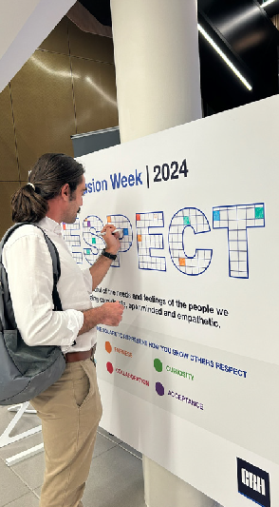
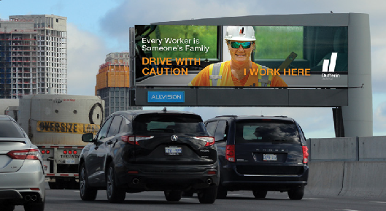


1For more information on how we champion innovative, sustainable solutions, please see page 80 of the CRH 2024 Sustainability Performance Report.


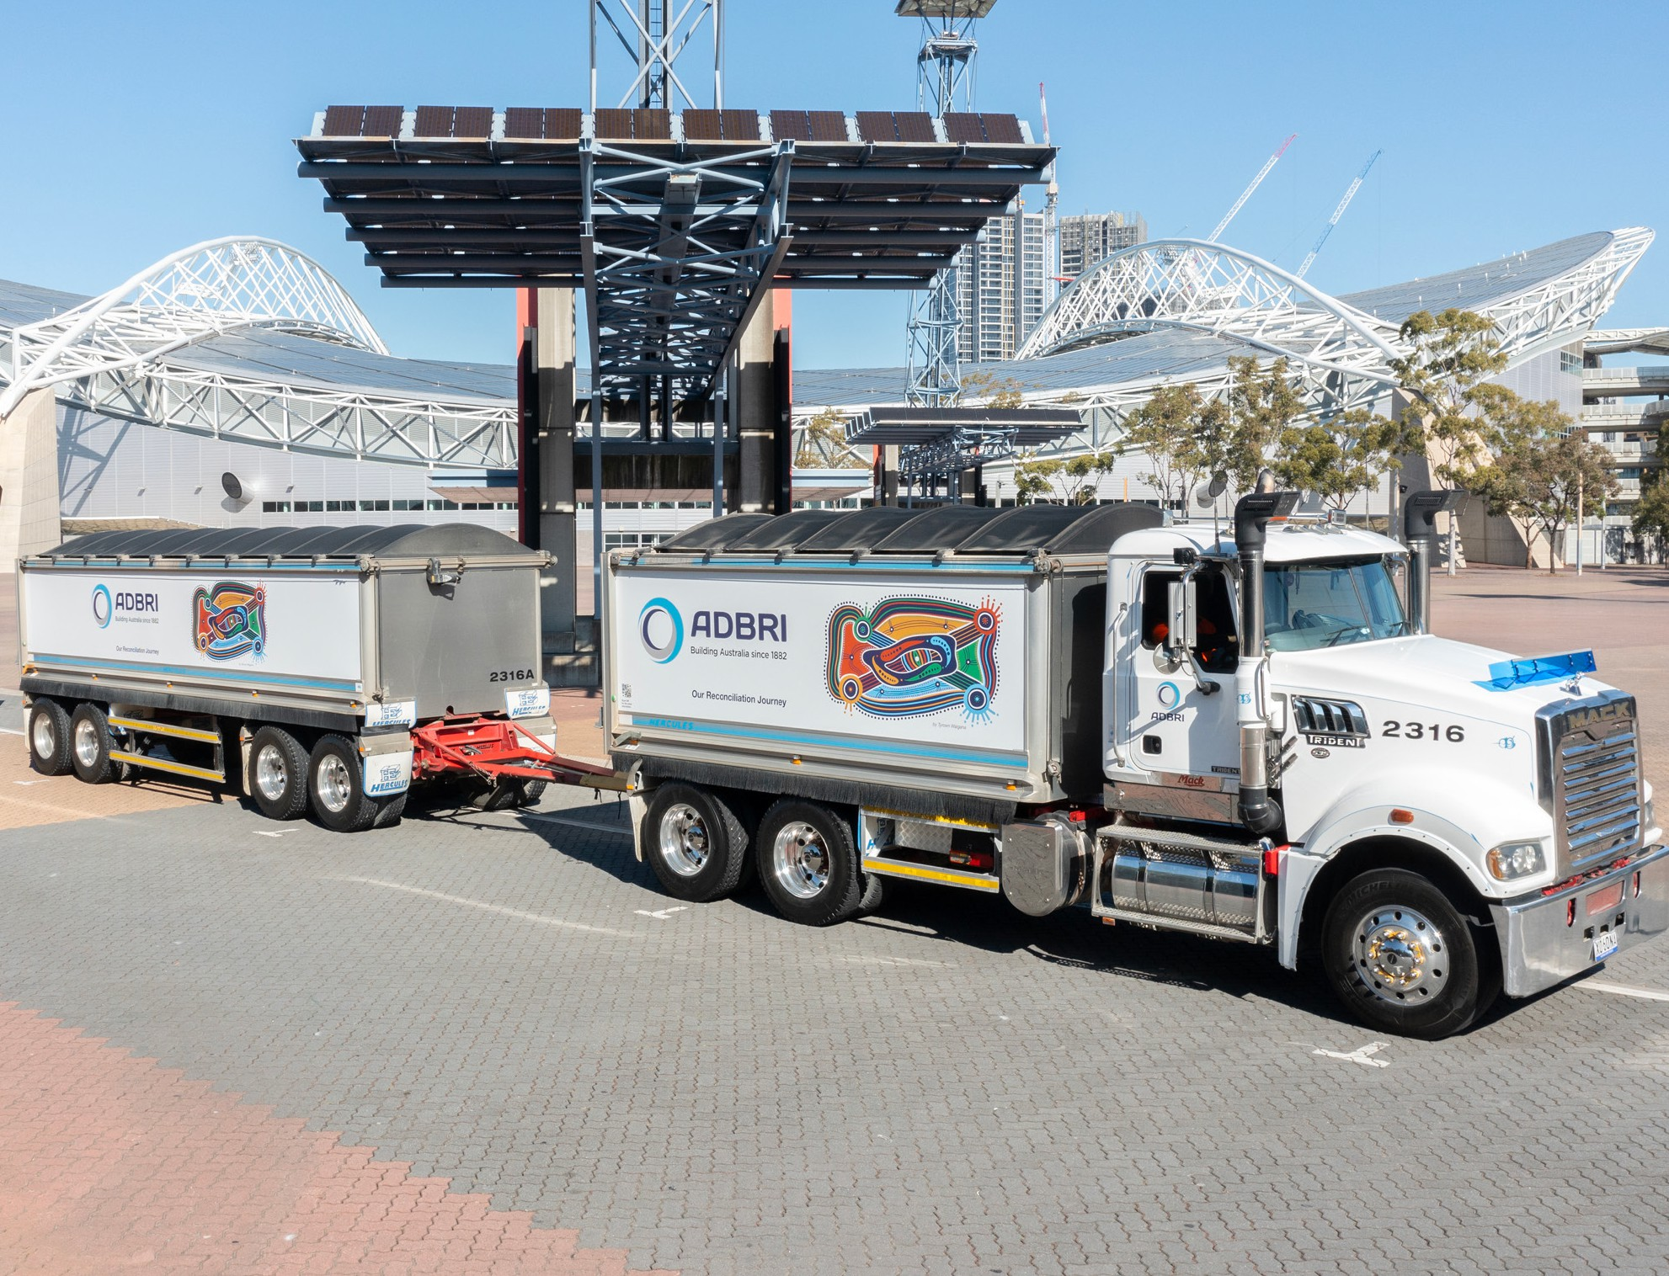

Case studies - continued

CASE STUDY

Collaborating with our stakeholders for positive change
Stakeholder engagement helps CRH to build strong relationships with the community and build trust with public bodies and approval agencies. As a responsible business, we recognize the importance of involving indigenous communities where appropriate, such as the Aboriginal and Torres Strait peoples in Australia, in such engagement.
CRH Canada, in CRH’s Americas Division, has developed a range of strategies to build an understanding of the
various needs of stakeholders. CRH Canada has developed Community Liaison Committee (CLC) panels at key
sites, consisting of neighbours, local politicians, local business leaders and other community representatives. This enables ongoing engagement to inform attendees about the operations and any relevant site related updates and exchange views on relevant business and community topics.
Adbri, in CRH’s International Division, operates a scalable approach to community engagement and for larger sites with potential for extensive interaction with the community, there are site-specific Community Engagement Plans
in place. As a company with sites across Australia, Adbri invests in reconciliation with Aboriginal and Torres Strait Islander peoples through its employees, suppliers, customers and local communities. In 2023, Adbri
launched its second Innovative Reconciliation Action Plan (RAP). Adbri’s reconciliation efforts championed by its Reconciliatory Action Plan Working Group Chair, supported by an independent Aboriginal advisor and four leaders who will drive progress across key focus areas. Adbri trucks featuring Aboriginal reconciliation artwork help promote awareness about the significance of inclusion and respect within our communities.

Internal due diligence

In 2024 operating companies completed detailed Health, Safety, Environment and Social assessments through our annual review process (‘Review Process’) and where possible, associates and joint venture partners also complete these assessments. The key objectives of these annual reviews are to verify the implementation of the CRH Health and Safety policy and Environment and Social policies, review performance against our salient human rights issues, and assess effectiveness of our programs. In 2024, these assessments were updated to reflect legislative changes.



Due diligence processes
We conduct human rights due diligence across our value chain, including our suppliers, our operations and all CRH acquisitions. Where necessary, mitigation plans are developed to remediate and prevent re-occurrences. For example, when acquiring companies, we carry out health and safety audits and implement improvement plans as needed, along with the necessary investment needed to protect the safety of employees, contractors, and the communities where we operate.
In 2024, CRH completed 40 acquisitions. Due diligence was carried out and included our Health and Safety audit programs and Human Resources checks.
As a result of these processes, specific plans were put in place to improve Health and Safety standards as required. Measures are taken to align the new acquisitions with the CRH Life Saving Rules. In some cases this may involve the installation
of further machine guarding, improving access to heights and pedestrian vehicle segregation. These improvement plans help progress our ambition to have a culture of safety and wellness, working towards zero harm across all operating companies. The performance of these companies is tracked through the specific health and safety audits and the Review Process, with these acquisitions being integrated into our reporting processes in 2024.
Assessment, mitigation and remedial actions
The 2024 Review Process measured key parameters across areas such as policy implementation, safety across the employee and contractor value
chain together with employee labor rights including discrimination, freedom of association, forced labor, and fair payment.
We assess nearly 90 human rights criteria. Data around employee development across different categories and types, including employee training, career development and employee engagement is also collected through the Review Process. Data is also collected around community engagement and the types of initiatives in place across CRH. The results of the Health and Safety, Environment and Social Reviews are included in reports to the SESR Committee.
As part of our CRH Health and Safety, Environment and Social Reviews, a human rights assessment is conducted annually. In addition, our operating companies complete individual human rights assessments and have systems in place to facilitate compliance with human rights requirements. Where issues are identified, mitigation plans are put in place to provide effective and satisfactory remedies to anyone affected.


Labor and employment practices
At CRH we respect our employees’ rights to take part in collective bargaining and to form and There were zero cases of forced or compulsory labor reported in 2024 and no reports of join trade unions. In 2024, approximately 19% of our employees were members of trade unions employees or contractors under the relevant legal working age at any location among our (20% in 2023) with some of our operating companies unable to disclose this information due businesses (zero cases reported in 2023). The Social Review also found that all migrant to legal restrictions. We also respect local wage and hour laws. Our operating companies workers have similar legal protection to other employees. Across the Group operating offer entry-level wages at or above the minimum wage, with companies having policies that companies work to comply with all required regulatory standards to prevent excessive prioritize fair and equitable remuneration. working hours.


As part of our Sustainability reporting, CRH’s approach to stakeholder engagement is reviewed as part of an independent assurance process for adherence to the AA1000 AccountAbility principles of inclusivity, materiality, responsiveness and impact.

Supply chain due diligence Our procurement process

We monitor compliance with our human and labor rights policies in relation to issues, such as modern slavery, across all operating companies and review labor practices on an annual basis. We increase our assurance and due diligence response in accordance with the perceived risk profile within our supply chain.
CRH Group Policies
Drivers Enablers

Methods we prescribe in our SCoC include:
- Direct engagement through regular communication, with an acknowledgment of the SCoC from suppliers.
- Internal due diligence processes, including assessments, third-party software, and other methods.
- External due diligence requiring suppliers to complete a questionnaire, for clarity and alignment.
- Integration of specific clauses within contractual provisions to support adherence to the SCoC.
- Direct site assessments, desktop assessments, or independent third party assessments requested by CRH, as necessary, with mutually agreed upon terms and procedures.
- Collaborative development of actionable plans to rectify identified non-compliances or improvements, as identified in the assessments referenced above. Our methods of assurance are determined by the nature of the purchase, the source country risk assessment, level of spend, and other factors that may be relevant.
- CRH reserves the right to terminate an existing contract with a supplier in the event of non-conformance with the SCoC and/or terminate an existing contract if a supplier declines participation in a remediation plan upon request.






Identifying the risks and potential risks, mitigating ahead of an event and prioritizing improvements.
Clear policies and processes reflect CRH commitments. Our SCoC is available on crh.com
Furthering of compelling cases for sustainability improvements,
including the why and how value is delivered to stakeholders.
Refining processes that enable personnel involved in procurement activities to meet the
growing requirements.
Risks and Priorities
Sourcing
Innovation
Collaboration

Processes to source in a more sustainable way integrated into procurement activities.

Innovation with third-parties to increase efficiency and reduce environmental and human rights impacts while lowering
total cost.

Collaboration between CRH and suppliers to increase trust and foster
improved relationships.

Global direct sourcing audit summary

We source goods and materials, in large part, from North America and Europe. Where we source directly from suppliers and manufacturers in other parts of the world, and using our own Global Direct Sourcing team, we undertake detailed audits on a cyclical basis for quality and responsible sourcing, to enable compliance with local, regional and international standards and requirements.
Unsuccessful
Critical Gaps
Base standard
Good

Unsuccessful
Multiple or unresolved issues leading to review and exit.
Inconsistent
Outstanding issues that are being worked on to meet our minimum standards.
Meets
Compliance with the audit conditions required to meet our SCoC.
Baseline Performance
Exceeds
Compliance with the audit conditions required to meet our SCoC with some areas of good practice and innovation.
Audit-identified critical gap trends
47%
43.5%
26%
27.5%
14%
15%
6%
9%
7%
5%
Health & Safety
Working hours
Environment
Wage and benefits
Labor Practices

2024 2023

100% of Corrective Action Plans were completed

Case study

CASE STUDY

Demonstrating performance throughout the value chain

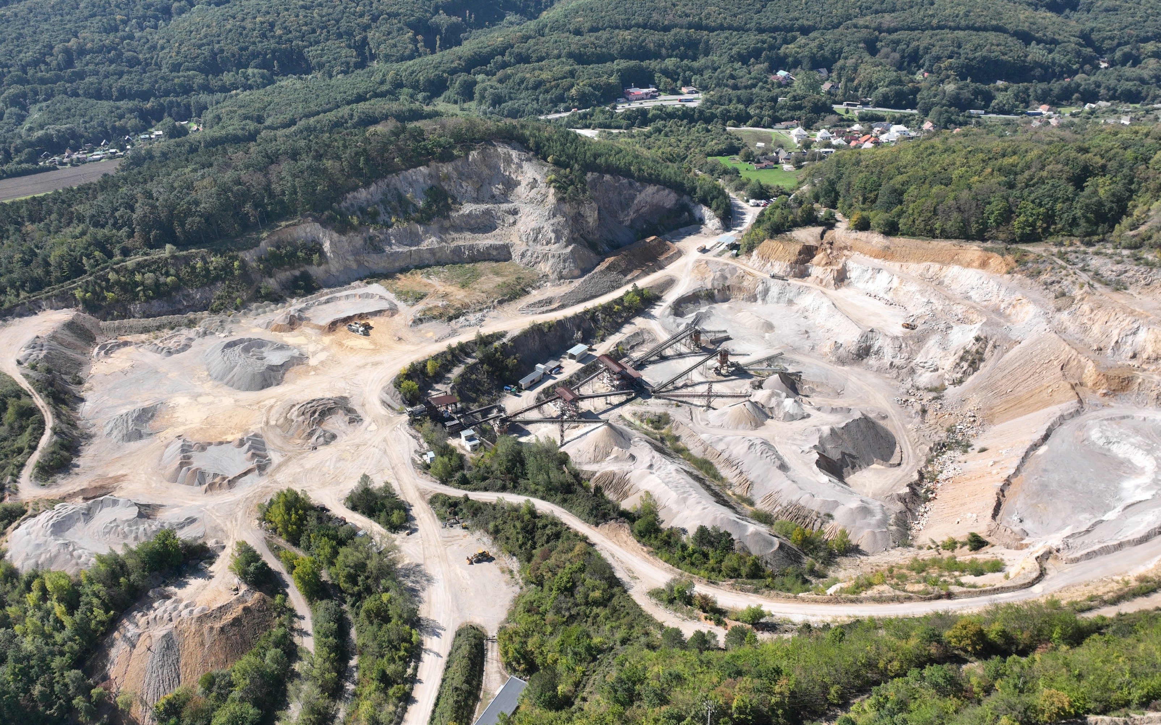


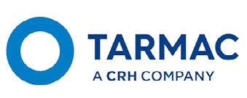
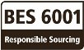

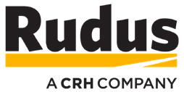
We engage with suppliers, governments, industry bodies, businesses, and other partners to support the transition towards more sustainable supply chains across the entire industry. We continue to demonstrate the sustainability credentials of our solutions to our clients and customers by achieving responsible sourcing certification of our products.
Customers look to us to provide solutions and insights into our shared responsible supply chains. To support this, CRH continues its active membership of the Concrete Sustainability Council (CSC). As a founding member, we helped to develop a responsible sourcing industry standard for concrete.
We have also partnered with the Global Cement and Concrete Association (GCCA), the Portland Cement Association in the U.S. and CEMBUREAU, the European cement association, on various projects to increase the sustainability of our supply chains to enable more sustainable buildings and infrastructure.
Ethical labor and business practices are a key element of the CSC scheme and it is aligned with the BES 6001.
The CSC and BES 6001 are the dominant responsible sourcing certification schemes in many markets and provide credits to the major building sustainability certification schemes BREEAM® and LEED®.

Excellent

Excellent

Training Speak Up Policy

At CRH, training is integral to ensuring that the protection of human rights is integrated into all levels of the business. Our investment in learning and development is key to embedding our culture and values, ensuring compliance, and attracting, retaining, and developing top talent.
All policies are available online for employees and the CoBC, the Speak Up Policy and the SCoC can be downloaded from crh.com. Everyone who works for CRH has a duty to read, understand, and abide by the CoBC. Relevant employees are required to complete formal CoBC training on an annual basis. Relevant employees, including employees who participate in industry associations and membership organizations, must also undergo Advanced Compliance Training (ACT) on a regular basis. An external auditor independently assures
the training completion rates are accurately reflected in CRH’s data for the Sustainability Performance Report each year.
Procurement teams are continuously trained in responsible sourcing issues, tools and techniques. In 2023, we updated our Modern Slavery e-learning and we continue to broaden its assignment to additional employees across the Group.*
The Modern Slavery e-learning was developed to increase employee awareness of modern slavery indicators and the steps to take to report any issues that can help stop modern slavery.
At CRH, we take a holistic approach to training. Our frontline leadership and senior management development programs include strategic modules covering the spectrum of human rights issues, including health and safety, developing an inclusive workplace and leading with integrity.
Our Speak Up Policy encourages a culture where employees, independent contractors, customers, suppliers and other stakeholders can raise good faith reportable concerns such as unsafe, inappropriate or illegal behaviour, or violations of any CRH policies or local laws. These can be reported through several secure channels. For example, employees can report issues to members of their management team or directly to the Legal and Compliance function. They can speak to an internal Speak Up Point of Contact in certain CRH businesses or, in the case of fraud and theft, to a dedicated Fraud Point of Contact in their business.
Concerns can also be raised through our CRH Hotline, a 24/7, independent, multi-lingual reporting service. This confidential service allows employees, customers, suppliers and other external stakeholders to raise good faith concerns they may have and provides the option for the concerns to be raised anonymously. We handle all concerns discreetly and professionally investigate them. Appropriate actions are taken based on investigation findings. Retaliation or reprisals are not tolerated. For more information about Speaking Up at CRH, please see our Speak Up Policy on crh.com.
A total of 441 concerns globally were raised or managed through the CRH Hotline in 2024. In 2024, a total of 48 closed Hotline investigations were reported as having resulted in disciplinary action. For more information see page 74 in the CRH 2024 Sustainability Performance Report, available on crh.com here.


Code of Business Conduct

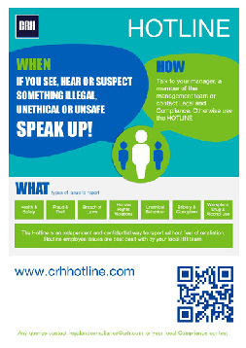
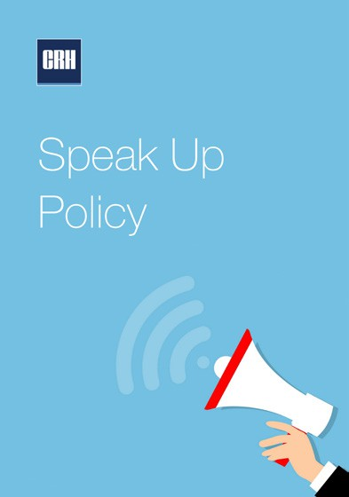
* For Canadian reporting entities, we further targeted the Modern Slavery e-learning, assigning it as mandatory training for certain senior managers and employees where the nature of their job function required more heightened awareness. In 2024, focused modern slavery training and related vendor risk assessment processes were developed specifically for employees that support procurement for the Canadian reporting entities.

CRH encourages employees and partners within its supply chain to “Speak Up”

Note on forward-looking statements


This document contains “forward-looking statements” within the meaning of the Private Securities Litigation Reform Act of 1995 with respect to the financial condition, results of operations, business and future performance of CRH.
These forward-looking statements include all matters that are not matters of fact at the date of this document, including statements about plans and expectations regarding actions taken and to be taken to prevent any form of Modern Slavery, sustainability outcomes, innovation, workplace inclusion, engagement and safety and social stewardship; expectations related to compliance with applicable regulations, reporting standards and requirements and policies; and expectations related to our impact on third party stakeholders and
the environment.
By their nature, forward-looking statements involve risk and uncertainty because they relate to events and depend on circumstances that may or may not occur in the future and reflect our current expectations and assumptions as to such future events and circumstances that may not prove accurate.
You are cautioned not to place undue reliance on any forward-looking statements. These forward-looking statements are made as of the date of this document, and we expressly disclaim any obligation or undertaking to publicly update or revise these forward-looking statements other than as required by applicable law.
For a discussion of some of the risks and important factors that could cause actual outcomes and results to differ materially from those expressed herein, see “Risk Factors” in the CRH Annual Report on Form 10-K for the year ended December 31, 2024, filed with the U.S. Securities and Exchange Commission on February 26, 2025.

Appendix 1 - Country specific requirements

Australian Specific Requirements
This is a joint statement of the entities listed in Appendix 2, which are reporting entities under the Australian Modern Slavery Act 2018 (Cth).
Consultation
Prior to being put to the Board of CRH plc for review and approval, this statement was prepared in consultation with our controlled entities, including the Australian reporting entities listed in Appendix 2. This included seeking input and endorsement from responsible management of those entities and representatives from relevant groups within the business.

Canadian Specific Requirements
This statement is the joint report pursuant to subparagraph 11(2)(b) of the Canadian Fighting Against Forced Labour and Child Labour in Supply Chains Act, SC 2023, c 9 (the “Act”) of CRH Canada Group Inc., Oldcastle Building Products Canada, Inc. and Ash Grove Cement Company (together, the “Canadian Reporting Entities”), for the financial year ending December 31, 2024.
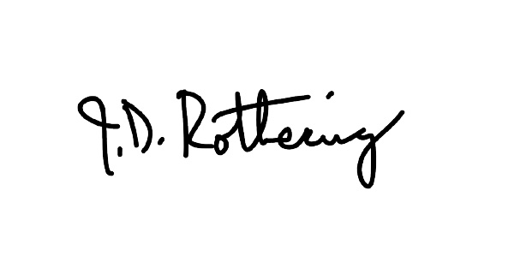
This statement was approved pursuant to subparagraph 11(4)(b)(i) of the board of directors of each of the Canadian Reporting Entities. In accordance with the requirements of the Act, and in particular section 11 thereof, I attest that I have reviewed the information contained in this statement for the entities listed above. Based on my knowledge, and having exercised reasonable diligence, I attest that the information in this statement is true, accurate and complete in all material respects, for the purposes of the Act, for the reporting year listed above.
Ash Grove Cement Company
John Rothering Director
Date: 20 May 2025
I make the above attestation in my capacity as a director of the board of Ash Grove Cement Company for and on behalf of the board of Ash Grove Cement Company. I have the authority to bind Ash Grove Cement Company.
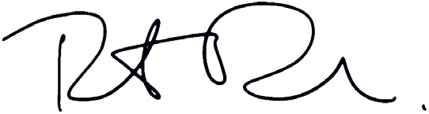

I make the above attestation in my capacity as a director of the board of CRH Canada Group Inc. for and on behalf of the board of CRH Canada Group Inc. I have the authority to bind CRH Canada Group Inc.
CRH Canada Group Inc. Robert Bourbeau Director
Date: 16 May 2025
I make the above attestation in my capacity as a director of the board of Oldcastle Building Products Canada, Inc. for and on behalf of the board of Oldcastle Building Products Canada, Inc. I have the authority to bind Oldcastle Building Products Canada, Inc.
Oldcastle Building Products Canada, Inc.
Timothy Ortman Director
Date: 20 May 2025

Appendix 2 - Reporting entities under the Australian Modern Slavery Act 2018 (Cth)

- CRH ANZ Pty Ltd
- Adbri Pty Ltd
- Adbri Masonry Group Pty Ltd
- Adbri Masonry Pty Ltd
- Adelaide Brighton Cement Ltd
- Cockburn Cement Ltd
- Hy-Tec Industries Pty Ltd
- Hy-Tec Industries (Queensland) Pty Ltd
- Hy-Tec Industries (Victoria) Pty Ltd
- Premier Resources Ltd
- Screenings Pty Ltd
- Adbri Concrete and Quarries SA Pty Ltd
- Southern Quarries Holdings Pty Ltd
- CRH Infrastructure Products Australia
- Infrastructure Products Australia Pty Ltd
- Holmes Nominees (Aust) Pty Ltd

- Tri Underground Australia Pty Ltd
- Burdens Australia Pty Ltd
- Infrastructure Products Australia Mouldings Pty Limited
- CTC Precast Pty Ltd
- CTC Management Pty Ltd
- Transfab Holdings Pty Ltd
- Precast Civil Industries Pty Ltd
- Concrete Solutions Holdings Pty Ltd
- Concrete Solutions Operations Pty Ltd
- Rocla Pty Limited
- Rocla Australia Pty Ltd
- Rocla Vic Pty Limited
- Rocla Concrete Pipes Pty Limited

CRH plc

Stonemason’s Way Rathfarnham Dublin 16
D16 KH51
Ireland www.crh.com
Registered Office
42 Fitzwilliam Square
Dublin 2 D02 R279
Ireland

CRH® is a registered trade mark of CRH plc.

